ME 3370
SOUTHERN METHODIST UNIVERSITY
DEPARTMENT OF MECHANICAL ENGINEERING
LAB 01: TRADITIONAL METAL CUTTING PROCESSES

Mohammed alafaisan
10/5/18

OBJECTIVE
This lab was conducted to get a proffer knowledge of traditional metal cutting. In this practical several machining processes were used to get the final shape using the given cylindrical rod. Initially turning operation was used to remove unwanted metal parts and obtain the given diameters of the given shape. Turning machine or lathe machine was able to do the turning process. Then milling operation was used to remove a portion of the metal part and make the drill hole. Finally, surface grinding was used to smooth the surfaces.
INTRODUCTION
Machining is a process in which a piece of raw material is cut into a desired final shape and size by a controlled material-removal process. The traditional metal cutting process uses tools, such as lathes, milling machines, boring machines, drill presses, or others, with a sharp cutting tool to remove material to achieve the desired geometry. Usually, there is a direct contact between the tool and raw material. These traditional machines are driven or operated with the help of human resource.
Around the middle of the 19th century, during the Machine Age was the time period that became a sudden development with the traditional machining processes, such as turning, boring, drilling, milling, broaching, sawing, shaping, planning, reaming, and tapping. During the age of World War II, sudden improvement was happen to the metal cutting method due to the new technology.
In modern nontraditional machines consist of new features in order to make metal cutting process easy. With conventional machines, long period of experience is required to gain very accurate cutting skill. But modern CNC machines less machining is required to cut a work piece. And conventional machines always work with single custom piece. For mass production the same process have to be repeated for many times. But in the case of modern conventional machines easily large number of parts can be reproduced. More advanced software can help to manufacture products which are difficult or nearly impossible to make on conventional machinery. The software can be updated as necessary to improve the CNC machine’s functionality. Many of the mathematical and analytical skills necessary to successfully operate traditional machines aren’t as emphasized in schools as they used to be. As a result, in one sense, there’s a less skilled workforce available. However, the modern workforce knows how to operate software and technology. And CNC machines certainly fit that mold better than conventional machinery.

EXPERIMENTAL PROCEDURE
Turning, milling and surface grinding was used for the making of a cylindrical part according to its specifications. First, the complete cylindrical component was placed on the machine according to the correct introductions, and then the turning was started. After placing the tool with required length, the cutting tool was fed axially towards the work piece while it was rotating around its axis. The cutting tool was fed towards the work piece until it reaches its required point. Then the tool was again taken back and make the process until the requirement was satisfied. The first surface was obtained as mentioned in above. Then by adjusting the lengths the second surface was obtained. And after the third surface was obtained according to the preferred measurements, the cylindrical part was parted.
To achieve the drilled hole milling process was applied. Using the required drilling tool which is required to obtain the 1 inch diameter, the process was carried on. The milling process was done until the required depth which is 1 inch was obtained.
Surface grinding was used to achieve a smooth surface on the work piece by removing excess materials and reduce the surface roughness. Using a rotating wheel, the grinding was obtained. Finally, micrometer screw gauge was used to measure the diameter of the work piece.
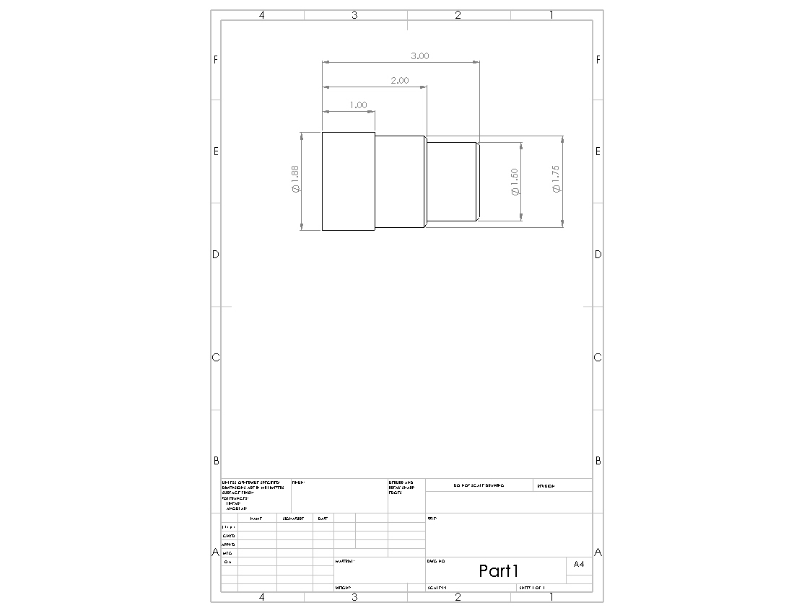
Figure 1: Manufacturing of cylindrical component

Table 1: Table of measured data
Surface number | Measurement (micrometer)
Surface 01 | 0.93
Surface 01 | 0.94
Surface 01 | 0.91
Surface 02 | 1.56
Surface 02 | 1.44
Surface 02 | 1.78
Surface 02 | 1.68
surface 03 | 0.88
surface 03 | 1.37
surface 03 | 0.88
surface 03 | 1.35
surface 03 | 1.46
surface 03 | 1.58
surface 03 | 1.55
surface 03 | 1.46
surface 03 | 1.48

Turning process
Turning is a machining process, which use a non-rotary cutting tool bit, which describe a helix tool path, by moving its along the work piece axis or preferred straight line while the work piece rotates around its axis and remove material parts. Turning can be done manually, which required frequent supervision through the process or by using an automated machines which can be identified as computer numerical control (CNC). The primary turning machine can be identified as the lathe machine, which can be able to do four different types of operation such as straight turning, taper turning, profiling or external grooving.
Turning can be done on outside of the work piece or the inside which is known as the boring. Furthermore several other turning operations can be identified.
- Tapered turning
- Spherical generation
- Hard turning
- Facing
- Parting
- Grooving
- Boring
- Drilling
- Knurling
- Reaming
- Threading
- Polygonal turning
Milling process
Milling process is a machining process which allows manufacturing of complex forms using materials such as metal, wood, plastics, composite etc. and meanwhile the removal of chips and processing residues. The primary machine which is used for the milling process are milling machines or machining centers. Milling requires a multi- sharp tool which used for rotation t mount on a spindle.
In this process the work piece is advance in the required direction towards the milling cutter. Also the cuter can be held at an angle relative to the axis of the tool. Same as the lathe machines, milling machine also manually operated or automatically operated such as CNC.
There are two major milling operations can be identified. They are face milling and peripheral milling. Face milling is used to cut flat surfaces into the work piece, or to cut flat-bottomed cavities. Peripheral milling is widely used for the cutting of deep slots, threads and gear teeth.
Surface grinding
Surface grinding is machining process which is used for achieve a smooth or flat surface. With the aid of the grinding wheel metallic or non-metallic material can be removed from a work piece, thus achieve a smooth surface.
A surface grinder is used for the surface grinding process to achieve a precision surface finish. The typical surface grinder working rage is depend on the type and the usage. There are several surface grinders which are used for surface grinding process.
- Horizontal-spindle (peripheral) surface grinders
- Vertical-spindle (wheel-face) grinders
- Disc grinders and double-disc grinders
RESULTS AND DISCUSSION
Table 2: Surface roughness calculated values
Spindle  Speed  (rad/s)10⁻⁵ | Feed rate  (In/rev) | Depth of cut  (in) | 3 sets of surface roughness values  (µm) |  |  | Mean standard surface roughness  (µm) | Standard deviation  (µm)
0.002618 | 0.0047 | 0.005 | 0.18 | 0.15 | 0.14 | 0.156666667 | 0.020817
0.002618 | 0.0047 | 0.02 | 0.32 | 0.18 | 0.29 | 0.263333333 | 0.073711
0.002618 | 0.019 | 0.005 | 0.93 | 0.89 | 0.83 | 0.883333333 | 0.050332
0.002618 | 0.019 | 0.02 | 3.02 | 3.25 | 3.13 | 3.133333333 | 0.115036
0.010472 | 0.0047 | 0.005 | 0.12 | 0.13 | 0.13 | 0.126666667 | 0.005774
0.010472 | 0.0047 | 0.02 | 0.22 | 0.17 | 0.18 | 0.19 | 0.026458
0.010472 | 0.019 | 0.005 | 0.93 | 0.94 | 0.98 | 0.95 | 0.026458
0.010472 | 0.019 | 0.02 | 1.02 | 0.99 | 0.98 | 0.996666667 | 0.020817

Selected data
Table 3: Selected Data for spindle speed vs. surface roughness
Spindle Speed (rad/s)10⁻⁵ | Feed rate  (In/rev) | Depth of cut  (in) | Mean standard surface roughness (µm)
0.002618 | 0.0047 | 0.005 | 0.156666667
0.010472 | 0.019 | 0.005 | 0.95

Table 4: Selected Data for Feed rate vs. surface roughness
Spindle Speed (rad/s)10⁻⁵ | Feed rate  (In/rev) | Depth of cut  (in) | Mean standard surface roughness (µm)
0.002618 | 0.0047 | 0.005 | 0.156666667
0.010472 | 0.019 | 0.005 | 0.95

Table 5: Selected Data for Depth of cut vs. surface roughness
Spindle Speed (rad/s)10⁻⁵ | Feed rate  (In/rev) | Depth of cut  (in) | Mean standard surface roughness (µm)
0.002618 | 0.0047 | 0.005 | 0.126666667
0.010472 | 0.019 | 0.005 | 0.19

Graph 1: Graph of spindle speed/feed rate/depth of cut vs. mean surface roughness

According to the above graph surface roughness is increased according to the other parameter increment. This happen because of the increment of spindle speed, feed rate and depth of cut the surface irregularities become increased. So that the final smoothness is reduced. To achieve a smooth surface all the parameters should be decreased.
But this kind of reduction can cause several disadvantages even though the surface finish is increased. Due to the low speeds and low feed rate the time consumption is increased and because of that the production efficiency is reduced. Also the cost is increased so that final product is economically failed. But due to the higher smoothness, the demand for product can be increased.
Working procedure of profilometer and stylus machine
Profilometer
Profilometer is a device which is used to measure the surface roughness of an object which gives the difference between the high and low point of a surface in nanometers. In profilometer there is a light source which emits a light beam and that light beam is split and reflected from reference and test material. In that process constructive and destructive inferences are occurred and forms light and dark bands known as interference fringes. Because of the height difference in the surface the optical path is varied. Interference image is taken by a camera and according to the image lighter areas can be identified as constructive interference areas and darker areas are destructive interference and those fringes represents one-half of a wavelength of difference between the reference path and test path. Two modes of operations are used in profilometer which is phase shifting interferometry (PSI) mode and the vertical scanning interferometry (VSI) modes.
Stylus machine
Same as the profilometer, stylus machine also used to measure the surface roughness. First, the measurement target is positioned. Then the target is visually inspected and check whether the texture of the target is periodic or non-periodic. When the sampling length is represented pictorially, measurements are performed with the sampling length indicated on the figure or in other information. If the target surface, corresponding sampling length is determined and measurement is performed. If the target surface is not periodic corresponding sampling length is determined from table 3 measurement is performed. And finally check, whether the parameters are within the threshold limit values from the measured results.
CONCLUSION
In this laboratory experiment a strong knowledge was gained about the metal cutting processes and was identified the difficulties of traditional metal cutting processes over non-conventional metal cutting processes. In here we had exposure to conventional machine practical experiences in milling, turning and surface grinding. The surface roughness data was measured using profilometer and stylish machines. Also different types of milling machine operations were identified and become familiarize with the milling machine. From the result which obtain from the practical, the surface roughness is increasing with the spindle speed, depth of cut and feed rate. Finally, surface grinding method was used to obtain a smooth surface for the metal specimen. Water cooling was used to cool the specimen for preventing overheating the specimen.

REFERENCES
[1] Keyence.com. (2018). Measuring Procedure for Stylus-Type Surface Roughness Instruments | Introduction To Roughness | KEYENCE America. [Online] Available at: https://www.keyence.com/ss/products/microscope/roughness/line/measurement_procedure.jsp [Accessed 4 Oct. 2018].
[2]ME-255: principles of tribology. Surface properties – Measurement techniques profilometer | Dept. of mechanical engineering, IISc | Balasenthil D | Sr.No. 08993 [Accessed 4 Oct. 2018].
[3]Belotti.com. (2018). Milling process. [Online] Available at: http://www.belotti.com/de-DE/milling-process.aspx [Accessed 2 Oct. 2018].
[4]Custompartnet.com. (2018). Turning Process, Defects, Equipment. [online] Available at: http://www.custompartnet.com/wu/turning [Accessed 2 Oct. 2018].
[5]En.wikipedia.org. (2018). Surface grinding. [online] Available at: https://en.wikipedia.org/wiki/Surface_grinding [Accessed 4 Oct. 2018].

